

­­­­­



**Solution Approach Document for I&M Bank**

**Retail/Corporate Customer 360**

**Version 2.2**





Solution Approach

For

Retail/Corporate Customer 360

By

Acidaes Solutions Pvt. Ltd.

Infospace, Tower 1, Ground Floor, Block B, Plot No. 2,

Sector 62, NOIDA - 201 309, UP, India;

Tel: (+91) 120 6784333; Fax: (+91) 120 6784334

Version: 2.2

Confidential and Proprietary

©Copyright 2011-2017, Acidaes Solutions Pvt. Ltd.

All Rights Reserved.

*The management team of Acidaes (the Company) has prepared this business document, and is being furnished to selected individuals within the I and M Bank for the sole purpose of proposal evaluation, for sale of CRMNEXT and CRMNEXT services. This business document is confidential, and contains ideas, concepts, processes and other information that the Company considers proprietary. Readers are to treat the information contained herein as confidential and may not disseminate, copy or reproduce it in any form without the expressed written permission of the Company. ‘Acidaes’, ‘CRMNEXT, ‘Simplifying Technology’ and ‘smart.easy.complete’ is applied trademarks of Acidaes Solutions Pvt. Ltd. All other trademarks are the property of their respective owners.*

Revision History

|  |  |  |  |  |  |
| --- | --- | --- | --- | --- | --- |
| **Sr. No.** | **Date** | **Version** | **Description** | **Author** | **Reviewer** |
| 1 | 20-5-2018 | 1.0 | Initial Draft | Manish | Imtiyaz |
| 2 | 22-5-2018 | 2.0 | Updated Based on discussion with Business | Manish | Imtiyaz |
| 3 | 28-5-2018 | 2.1 | Updated for Individual field list Basis discussion with Fred | Manish | Imtiyaz |
| 4 | 28-5-2018 | 2.2 | Updated based on Kishen inputs | Manish | Imtiyaz |

Table of Contents

1 Scope of the Document 5

1.1 Coverage of the document 5

2 Definitions 6

2.1 Individual Banking: 6

2.2 Group Banking: 6

2.3 Customer 360° View: 6

2.4 Data boot up: 6

2.5 Alerts: 7

2.6 Views: 7

2.7 Fields: 7

3 Abbreviations 7

4 Roles and corresponding Customer Access 9

5 Customer Search 10

6 Customer 360° 10

6.1 Individual 10

6.1.1 Detail/Classic View 11

6.1.2 Card View 13

6.2 Corporate 21

6.2.1 Detail/Classic View 22

6.2.2 Card View 41

6.3 Prospects 51

7 Views 51

7.1 Individual 51

7.2 Corporate 52

8 Interacting Systems 52

9 Other Integration Systems 54

10 Assumptions 54

11 Fields 55

11.1.1 Customer Field List – Individual 55

11.1.2 Customer Field List – Corporate 56

# Scope of the Document

Scope is to establish a single console powered by strategy and process to manage the multi-channel customer experience, align an organization around high-potential customer and build a loyal, profitable customer base. This is a single console where all the information of the customer is consolidated and forms a Customer 360° view. It will help unify service consoles, cross sell and provide easy access to information at various customer touch points.

## Coverage of the document

This document will cover following Sections in terms of proposed solution across all segments within I&M Bank.

* 1. Definitions
  2. Abbreviations
  3. CRMNEXT understanding on Segments
  4. Roles and corresponding Customer Access
  5. Customer Search
  6. Customer 360°
  7. Views
  8. Data Loading
  9. Integrating Systems and Integration Methodology
  10. Alerts

# Definitions

## Individual Banking:

Customer individually in relation with bank will fall under Individual Banking.

1. This covers customers falling under segments such as
   1. Personal Banking – Example Retail Customers
   2. Premium Banking – Example Directors of Corporate etc.
2. The solution in terms of Screen Layout will be common across both segments. The data will be bifurcated/available to Users of a segment through predefined roles (segment wise).

## **Group Banking:**

Customer in business relation with bank as group entity will fall under Group Banking.

1. This covers customers falling under segments such as
2. Corporate & Institutional Banking
3. Business Banking
4. The solution in terms of Screen Layout will be common across both segments. The data will be bifurcated/available to Users of a segment through predefined roles (segment wise).

## **Customer 360° View**:

It will contain one view of customer across various systems within bank. There will be 2 types of views available namely

1. **Card View**:-Card view will be the summarized view. The details of the same are mentioned in the later sections.
2. **Detail/Classic View**: - This will contain detailed view of the customer data.

## **Data boot up:**

This section contains methodology to be used for the creation of customer records within CRMNEXT one time during bootup and incrementally.

1. **Static Data**: The frequency of change of such data is rare such customer profile data.
   1. Hence, such data will be stored in CRMNEXT from core systems as part of time customer bootup.
   2. The changes such data in core system will be incrementally brought into CRMNEXT through day end batch jobs.
2. **Transactional Data**: Data which are transactional in nature and can be changed frequently will be shown as part of mash up data on Realtime basis from core systems, such account financial transaction details etc.
3. **Other Data**: Data which are purely gathered from relationship and can be captured directly into CRMNEXT as editable fields. This data will not flow back to Core Systems.

## **Alerts:**

The various types of alerts will be available for user actions. These are explained in corresponding sections of document.

## Views:

Views or in other words buckets details will contain listing of customers based on customer search criteria as well as role of the customer.

## Fields:

Fields are various types of customer attributes. Important is to finalise details such as length, type, validation etc.

# Abbreviations

Please find the list of abbreviations used in the document below:

Table 1 List of Abbreviations

| **Sr. No.** | **Abbreviation** | **Description** |
| --- | --- | --- |
|  | Bank CRM | Product developed and configured by CRMNEXT to cater the needs of I&M Bank for “Customer Relationship Management” |
|  | CIF | Customer Information File |
|  | ETB | Existing to the Bank |
|  | NTB | Non existing to the Bank |
|  | LOS | Loan Originating system developed by Polaris for Foreign Offices |
|  | ETL | Extraction, transformation and loading |
|  | T+1 | The data will be available 1 day later in Bank CRM than Finacle & other core systems. |
|  | CIB | Corporate and Institution Banking |
|  | BB | Business Banking |
|  | PEB | Personal Banking |
|  | PrB | Premium Banking |
|  | SH | Segment Head |
|  | BM | Branch Manager |
|  | RM | Relationship Manger |
|  | CSO | Customer Service Officer |
|  | RA | Relationship Analyst |
|  | CBS | Core Banking Sytem |
|  | LOS | Loan Origination Sytem |
|  | IMS | Investment Management System |

# 

# Roles and corresponding Customer Access

* + 1. The following attachment describes the roles that will be configured in the CRM system and their access rights. Currently it is from corporate perspective.



# Customer Search

1. Please refer to the solution Approach “Corporate Sales Management” under section “Search Customer” for further details.

# Customer 360°

Customer 360 will have a holistic view of the customer, it will display the information stored in CRMNEXT as well as information stored in other systems which will be available on demand basis. It will display information such as demographics, products, activities, leads, deals, account planning and service desk requests. Following are the screens of customer 360 that will be available, it is majorly divided into two views:

1. Card View
2. Classic View

On customer segment level customer 360 will be divided into two parts

1. Individual
2. Corporate Banking

Following is the bifurcation of customer 360 in pictorial form:

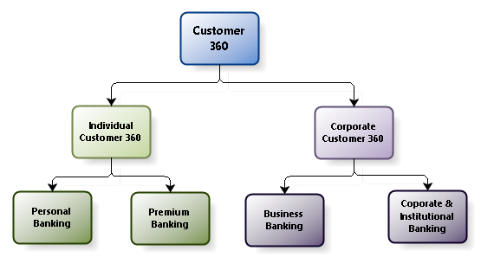

Figure 1 Customer Classification

## Individual

Individual view of the customer 360 will incorporate customers with following segments

1. Personal Banking
2. Premium Banking

## Detail/Classic View

The excel sheet list down the list of fields finalized. Codes of same will be checked on the Core system and that will be supercede the values listed.



1. Below is the classic/detail view of individual customer

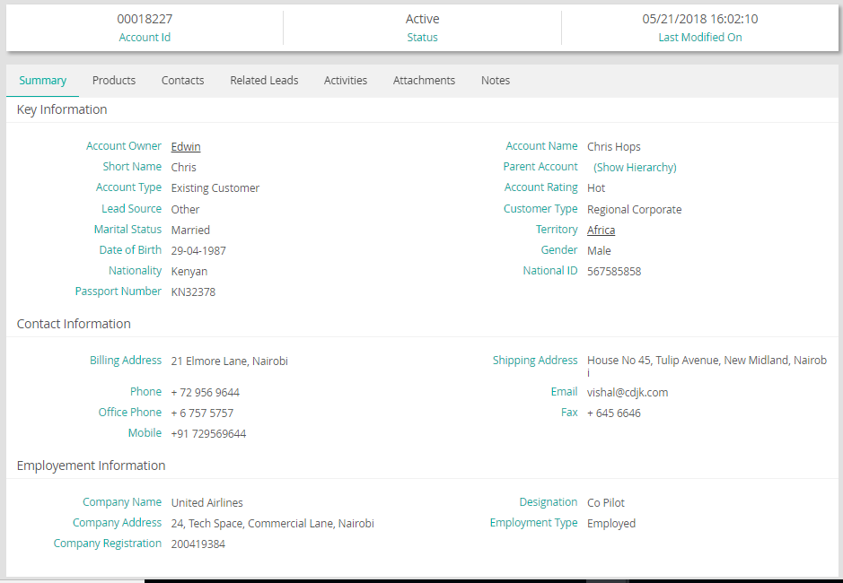

Figure 2 illustrative Classic view

1. Below is the illustrative edit screen of Individual customer.  
   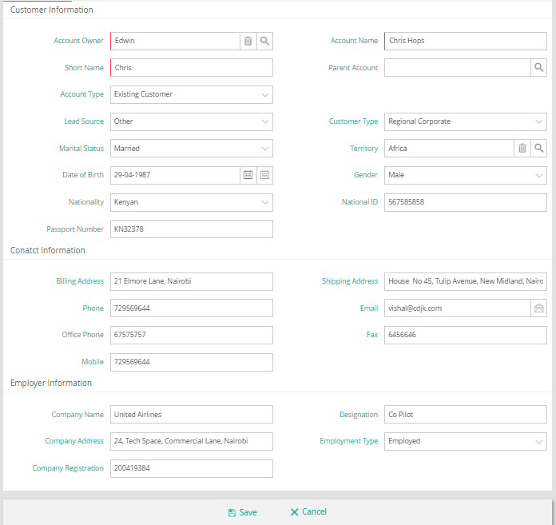

Figure 3 Individual 360 Detail View

* 1. The fields received from Core and other systems will be readonly.
  2. The fields available in “Bank CRM” only will be available for edit for RM, RA, PH Rep etc.

#### Summary Tab

1. Following screen displays the summary details of Customer.

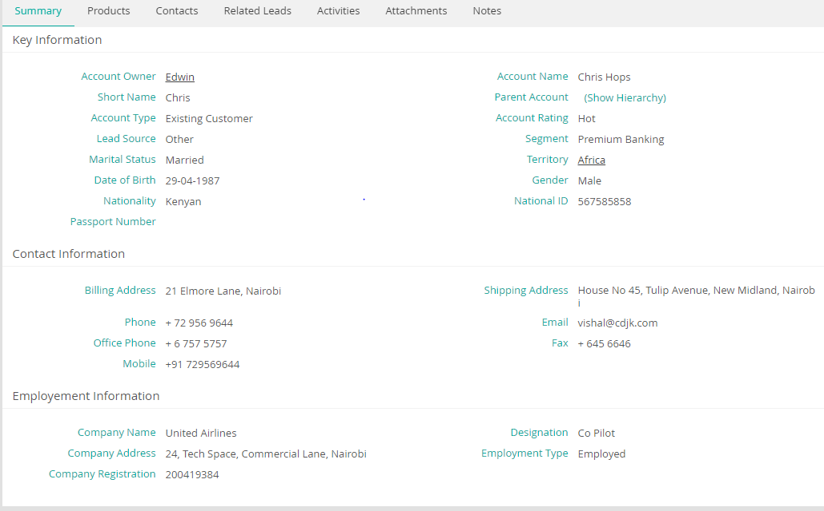

#### Products holding

This card will display all the products that a customer has in its portfolio. Account related information will not be stored in CRMNEXT and will be fetched from external system on demand basis through mashups. Below is illustrative screen of same for reference-

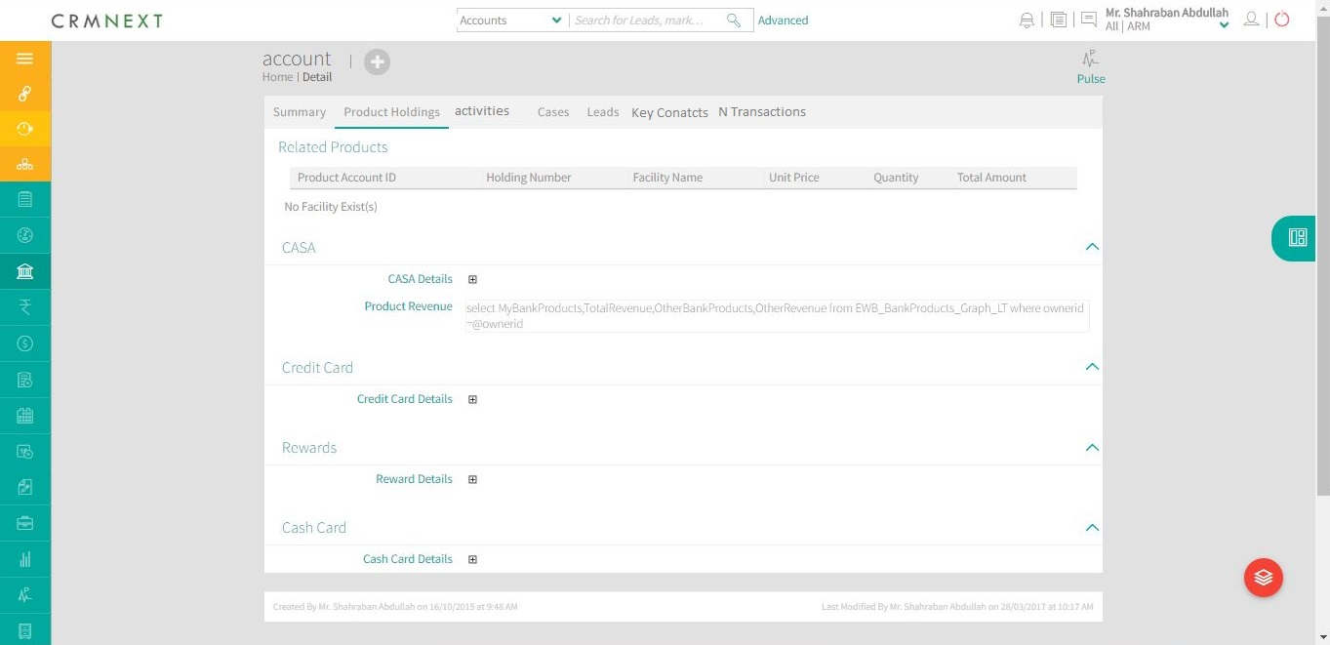

#### Contact

This tab of customer will display all the related contacts for that individual. Below is illustrative screen of same for reference-

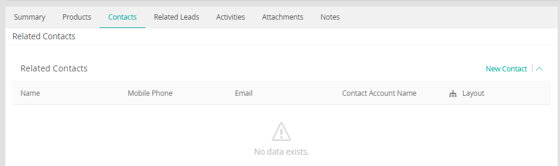

#### Activities

This tab of customer will display the activities created by the RM/CSO for follow-up/appointment etc with the customer. Below is illustrative screen of same for reference-

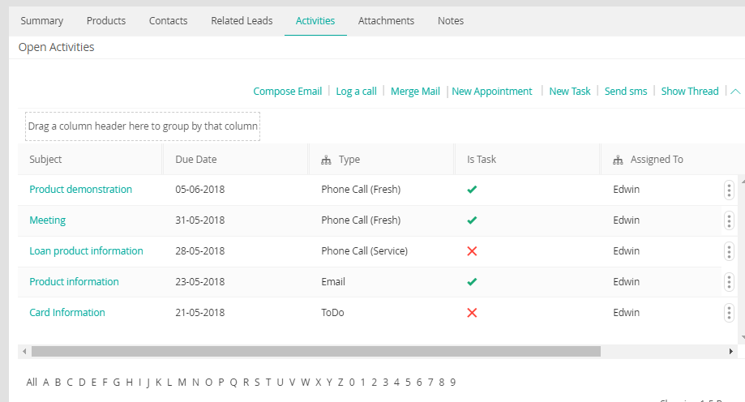

#### Attachment

This tab of customer will display all the attachment values that is associated with the customer. Below is illustrative screen of same for reference-

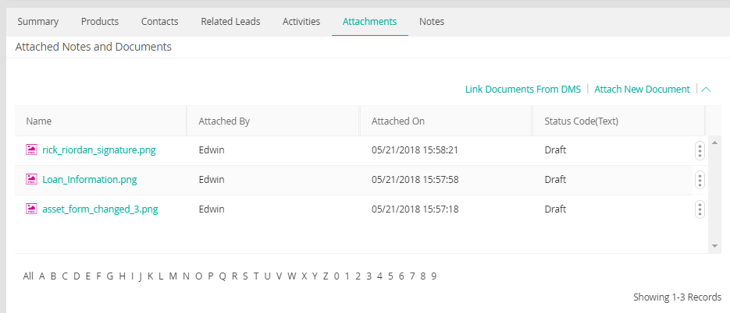

#### Notes

This tab of customer will display the notes created on the customer. Below is illustrative screen of same for reference-

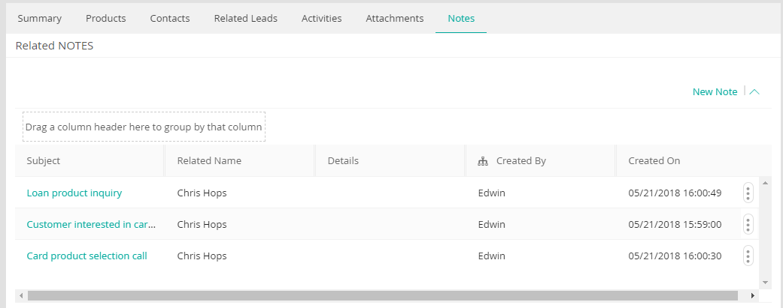

## Card View

Following are the card view screenshots for Individual customer.

#### Customer Profile

Customer profile card will be divided into three parts namely: summary, contact and employer information

##### Summary

This will be a part of profile card and will display the demographic details of the customer.

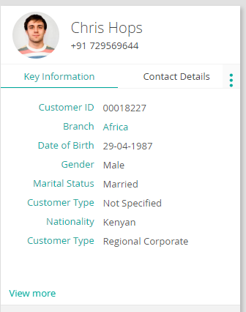

Figure 4 Illustrative Key information card

##### Contact

This will be a part profile card and will display all the contact related information of the customer.

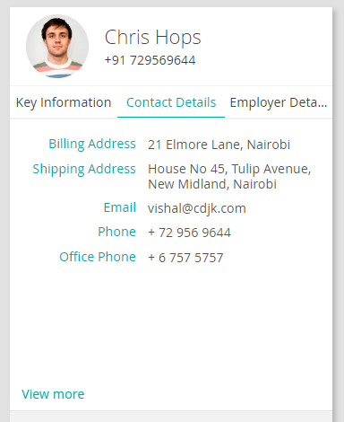

Figure 5 Illustrative Contact Card

##### Employer Information

This will be a part of profile card and will display the employment details of the customer.

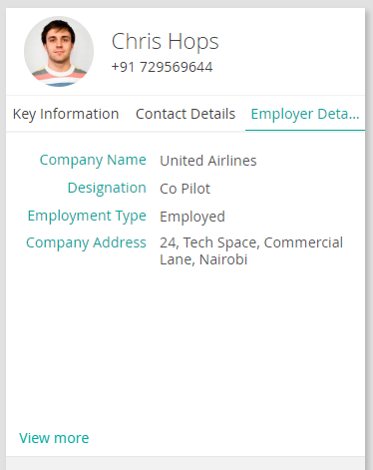

Figure 6 Illustrative Employment Details

#### Product Holding

This card will display all the products that a customer has in its portfolio..

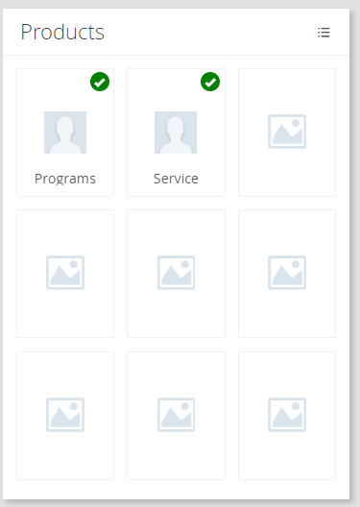

Figure 7 Illustrative Product view

#### Related Leads

This card will display the leads of existing customer for different products that he/she is interested in.

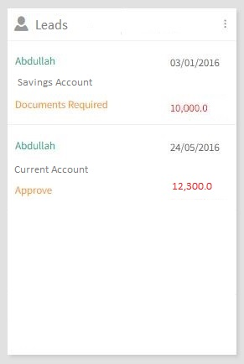

Figure 8 Illustrative Lead Card

#### Related Activities

This card will display the activities created by the RM/CSO for follow-up/appointment etc with the customer.

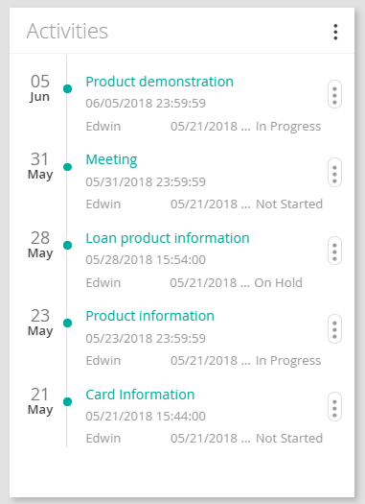

Figure 9 Illustrative Activities Card

#### Attachments

This card will let the end user to enter the notes and Attachments for that respective Customer

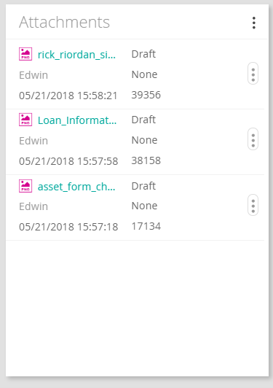

Figure 10 Related Attachment Card

#### Notes

This card will let the end user to enter the notes for that respective Customer

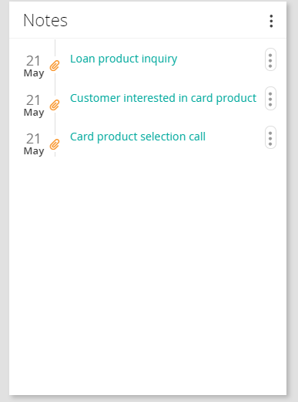

Figure 11 Related Notes card

## Corporate

Corporate view of the customer 360 will incorporate customers with following segments

1. Business Banking
2. Corporate and Institutional Banking

## Detail/Classic View

1. Below is the classic/detail view of corporate customer.  
   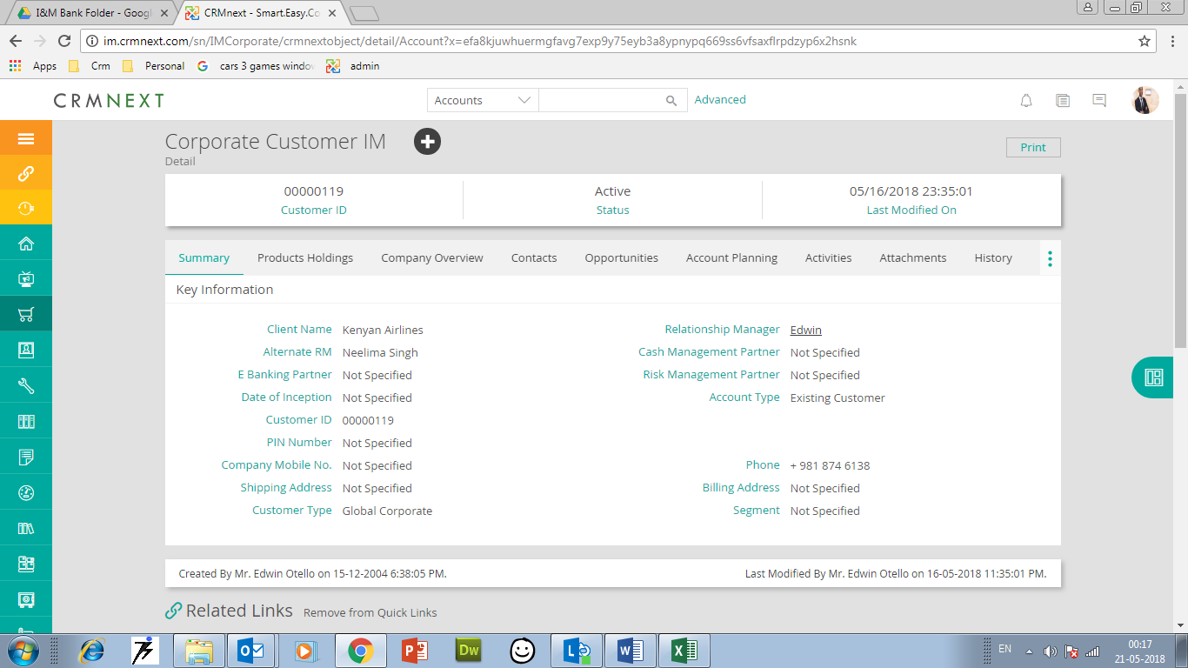

Figure 12 Illustrative Corporate 360 Detail View

1. Below is the illustrative edit screen of corporate customer.  
   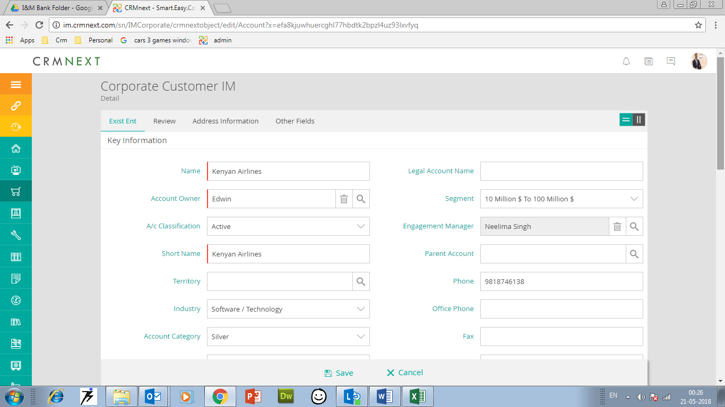

Figure 13 Corporate 360 Detail View

* 1. The fields received from Core and other systems will be readonly.
  2. The fields available in “Bank CRM” only will be available for edit for RM, RA, PH Rep etc.

#### Company Overview

1. **Fields**: Below excel showcases all the fields to be displayed in the company overview. Various sections will be used to showcase the information – Namely Summary, PH partners, Company Information, Account Revenue Information, Credit information, Client financial, Employee details, Competition.



#### Product Holding

1. Fields – Please find the attached excel listing down all the fields of Product holding.



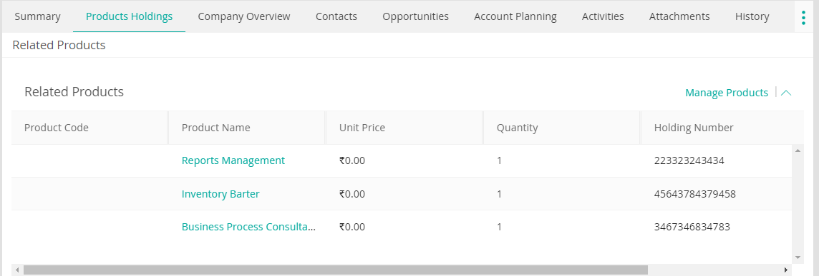

Figure 14 Illustrative Product Holding screen

#### Related Contacts

1. Fields

Table 4 Related Contacts Fields

|  |  |  |  |  |  |  |  |  |  |
| --- | --- | --- | --- | --- | --- | --- | --- | --- | --- |
| **Section** | **Field Name** | **Field Description** | **Values** | **Data type** | **Field Size** | **Mandatory** | **Source of field** | **Comments** | **Validation** |
| Contact Information | Contact Type | Dropdown | Distributors/Clients Suppliers Key Contacts Directors Shareholders Management |  |  |  |  |  |  |
| Title |  |  |  |  |  |  | Applicable for Management/Key contacts |  |
| First Name | ` | Aphanumeric (40) | Text |  | Yes |  |  |  |
| Middle Name |  | Aphanumeric (40) | Text |  |  |  |  |  |
| Last Name |  | Aphanumeric (40) | Text |  | Yes |  |  |  |
| % Share holding |  |  |  |  |  |  | Applicable for shareholders, upto 100% |  |
| Mobile |  | Mobile | Text |  | Yes |  |  |  |
| Email Address |  | Email | email |  | Yes |  |  |  |
| Annual Volume of business (Ksh'm) |  | Number(3) | Amount |  | Yes |  |  |  |
| Banked by I&M |  | Yes No | Picker |  | Yes |  |  |  |
| Address |  | Aphanumeric(80) | Text |  |  |  |  |  |
| Country |  |  | Picker |  |  |  |  |  |
| Relationship Information |  | Aphanumeric (1024 ) | Text |  |  |  |  |  |
| Relationship Manager |  |  | Dropdown |  |  |  |  |  |
| location |  | Aphanumeric (40) | Text |  |  |  |  |  |
| Comments |  | Aphanumeric (1024 ) | comment |  |  |  |  |  |

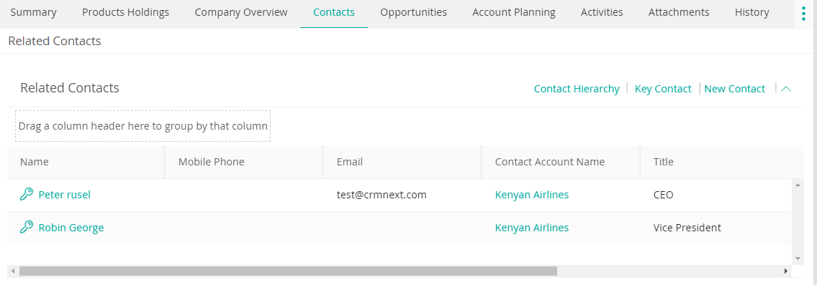

Figure 15 Illustrative Figure of Related Contacts

#### Related Deals

1. Fields-

Table 5 : Fields for Related deals

|  |  |  |  |  |  |  |  |
| --- | --- | --- | --- | --- | --- | --- | --- |
|  | Product | Deal Amount for I&M | Size of Wallet for All Banks(Ksh) | Projected I&M share of wallet | Expected I&M Revenue | Deal Status | Expected month of closure |
| 1 | Bancassurance:Aviation | 1000000 | 100000 | 80% | 80000 | Initiated |  |

Date (expected month) Of closure?---- Added

1. Illustrative Screen –

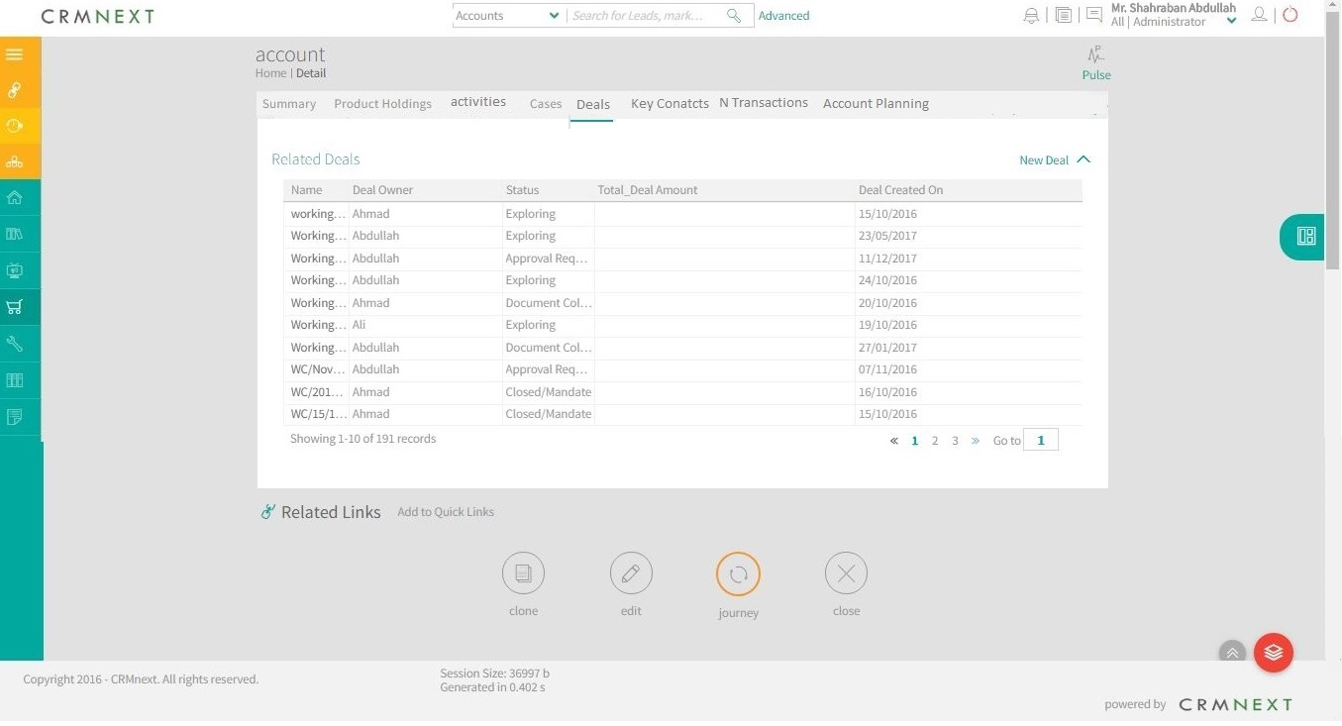

Figure 16 illustrative figure for Related Deals

#### Related Activities

1. Fields

Table 6 : Related Activities Fields

|  |  |  |  |  |  |  |  |  |  |
| --- | --- | --- | --- | --- | --- | --- | --- | --- | --- |
| **Section** | **Field Name** | **Field Description** | **Values** | **Data type** | **Field Size** | **Mandatory** | **Source of field** | **Comments** | **Validation** |
| Key Information | Start Date |  |  | Date |  |  |  |  |  |
| Due Date |  |  | Date |  |  |  |  |  |
| Assigned To |  |  | Multiplicker |  | Yes |  |  |  |
| Subject |  |  | Text |  | Yes |  |  |  |
| Description |  |  | comment |  |  |  |  |  |
| Task Type |  |  | Picker |  | Yes |  |  |  |
| Status |  |  | Picker |  | Yes |  |  |  |
| Priority |  |  | Picker |  |  |  |  |  |

1. Illustrative Screen on detail page –

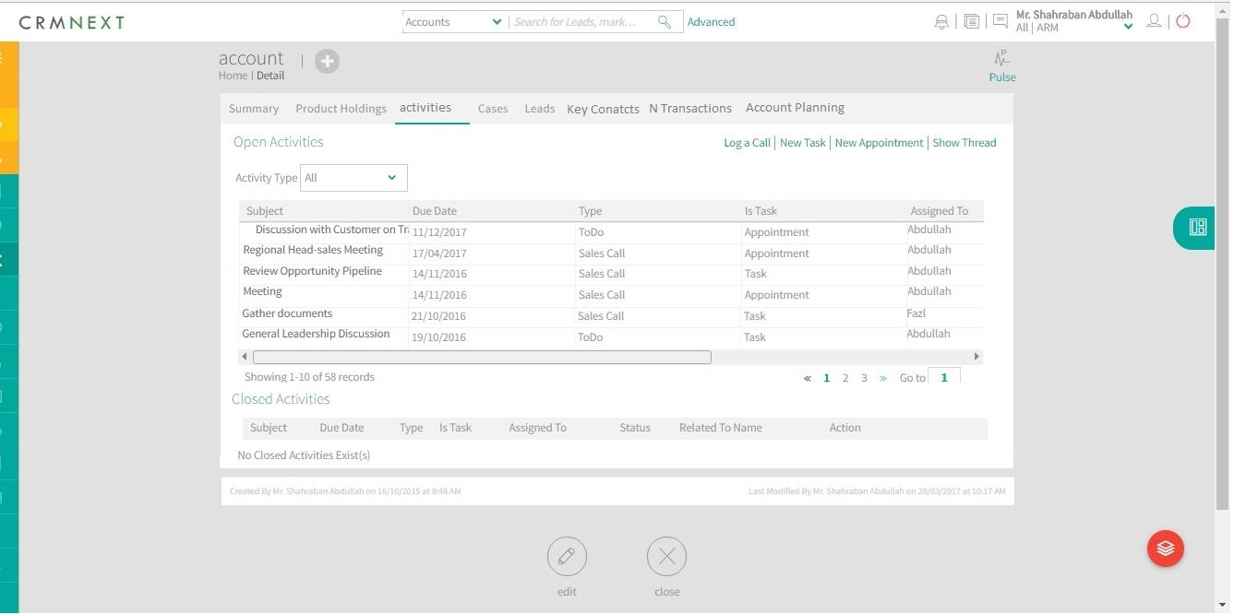

Figure 17 Illustrative Screen of Activities

#### Related Cases

Informations to be provided from the Service desk/Mantis team

#### Financial Transactions

Information to be provided from the core system. Please note same can also be shown under Product holding tab.

#### Finacle Treasury

Information to be provided from Treasury Team.

#### Banc- Assurance

Information to be provided from Bancassurance Team

#### Card System

Information to be provided from Card Management Team

#### IMS

Information to be provided from IMS Team

#### Trade Finance

Information to be provided from Trade Finance Team.

#### DMS

Information to be provided from DMS Team.

#### LOS

Information to be provided from LOS Team.

#### Vision

Information to be provided from Vision Team.

#### Account Planning

Please refer the section 10.2.5 of document name – Corporate Sales Management_IM_v1.3

#### Pipeline Analysis

Please refer the section 10.2.6 of document name – Corporate Sales Management_IM_v1.3

## Card View

Following are the card view screenshots for corporate customer.

#### Customer Profile

Customer profile card will be divided into three parts namely: summary, contact and Financial information

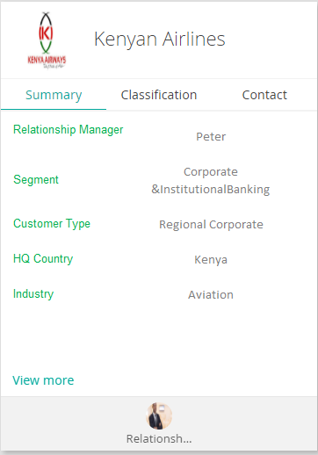

Figure 18 Illustrative Customer Profile card

##### Summary

This will be a part of profile card and will display the main summary details of customer.



Figure 19 Summary Card

##### Contact

This will be a part of profile card and will display all the contact related information of the customer.

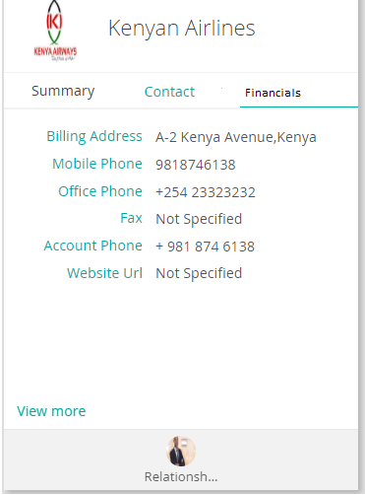

Figure 20 Contact section

##### Financials

This will be a part of profile card and will display the financial details of customers. Same will be updated from core system.

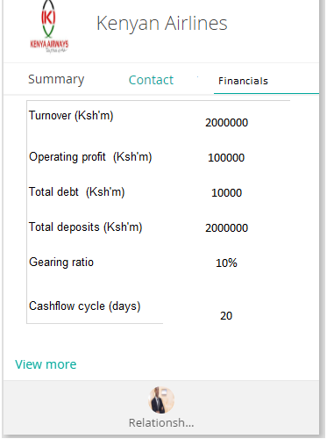

Figure 21 Financials section

#### Customer Key Contacts

This card will display the key contacts of the customer. These will be the contacts of people to which client is professionally or contractually related. These contacts can be converted to leads as well.

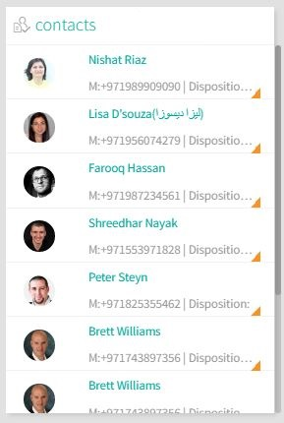

Figure 22 Illustrative Contact card

#### Related Deals

This card will display the deals of existing customer for different products that client is interested in.

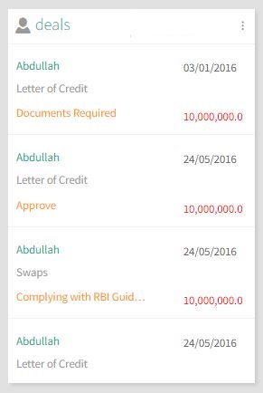

Figure 23 Related Deals Card

#### Related Activities

This card will display the activities created on the customer.

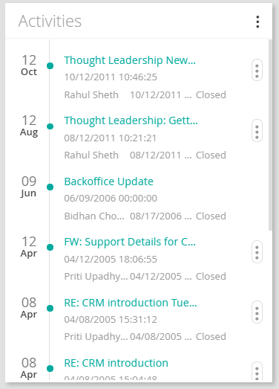

Figure 24 Related Activities Card

#### Product Card

This card will display all the products that is currently tagged against the customer.

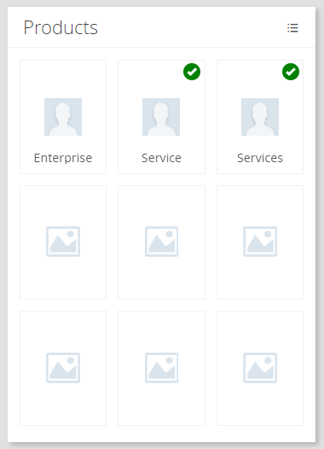

Figure 25 Related Products Card

#### Attachments

This card will display all the attachments related to the account and also will allow to add new attachment.

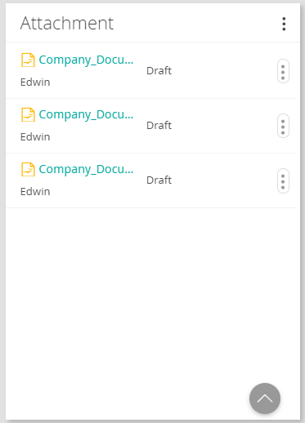

Figure 26 Attachments Card

## Prospects

Please refer the section number 3 (Prospecting Process) of document name – Corporate Sales Management_IM_v1.3

# Views

## Individual

As per the segmentation provided by the bank for its customers the following views will be configured in the CRMNEXT system for individual customers i.e. personal and premium banking customers.

|  |  |  |  |  |  |  |
| --- | --- | --- | --- | --- | --- | --- |
| **Sr. No.** | **Name of the View** | **Description** | **Condition Codes** | **Columns** | **Access To** | **Action Button** |
| 1. | Personal Banking Customers | All Personal Banking Customers | Status = Active  Segment Type= Personal Banking | TBD | All Users | N/A |
| 2. | Premium Banking Customers | All Premium Banking Customers | Status = Active  Segment Type= Premium | TBD | All Users | N/A |

**Table 7 Individual Views**

## Corporate

As per the segmentation provided by the bank for its customers the following views will be configured in the CRMNEXT system for corporate customers i.e. business, corporate and institutional banking customers.

|  |  |  |  |  |  |  |
| --- | --- | --- | --- | --- | --- | --- |
| **Sr. No.** | **Name of the View** | **Description** | **Condition Codes** | **Columns** | **Access To** | **Action Button** |
| 1. | Business Banking Customers | All Business Banking Customers | Status = Active  Segment Type= Business Banking | TBD | All Users | N/A |
| 2. | CIBBanking Customers | CIB Customers | Status = Active  Segment Type= CIB | TBD | All Users | N/A |

**Table 8 View for Group Banking Customer**

# Interacting Systems

I&M bank systems consists of multiple individual systems that are connected to a middleware, this middleware in turn is connected to a core banking system. It is to be noted that no other system apart from middleware is directly connected to CBS. CRMNEXT will also connect to Fiorano for data interchange with any of I&M bank’s system.

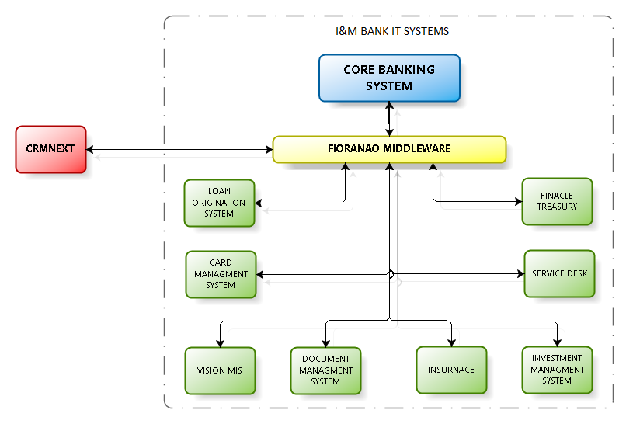

Exhibit: Interacting Systems of I&M Bank

1. **Core banking System:** Core banking systems has the majority of customer data. CBS deals primarily in customer demographics and financials.
2. **Loan Origination Systems:** LOS will process all the loan related information and keep the record of all customers that have opted for loan product.
3. **Card System:** CMS will store all the card related details of the customer.
4. **Insurance System:** Insurance systems will store the insurance details of customer.
5. **Finacle Treasury:**
6. **Document Management System:** DMS will have store all the documents of the customer in one place and will provide access as and when required by other systems.
7. **Sales Force Effectiveness tool:** Sales force effectiveness tool is an in house developed tool that captures lead and hands it down to RM/CSO/BM for further processing. Its functionalities will be handled by CRMNEXT.
8. **Vision for MIS reports:** This is a Business Intelligence tools that feeds data to SFE and other systems.
9. **Service Desk:** Service desk is a ticketing system keeps track of any information update on an existing customer data.
10. **Campaign Management tools**: This consists of an in house developed tool and some third party tools that all together run the campaigns for I&M bank. Tools used for campaigns are to be studied for Integration or replacement on case to case basis.
11. **Fiorano**: Fiorano is a middleware application that communicates with all the systems.
12. **Investment Management Services** (IMS) system: This systems is used for investing in Government Bills and Stock Market through the Bank’s IMS department.

# Other Integration Systems

Apart from above mentioned systems there will be some systems that will not directly integrate with CRMNEXT but will have data interchange with CRMNEXT one way or other. These type of systems are mentioned below:

1. Website: Data from website will be keyed into CRMNEXT manually by an agent and assigned to respective RMs.
2. Email: Leads from I&M bank’s official email ids will be created in CRMNEXT through email syndication. These leads will then be manually assigned to respective RMs the agent handling the email related leads.

# Assumptions

1. **Unique records:**
   1. Unique Key: All individual customers will have a unique Cust ID which will form basis for getting boot-up data, incremental and related customer data.
   2. All accounts in CRMNEXT should have unique account number.
   3. Record Tagging: The Demographic/contact/Product/RM/Other details of the corresponding customer would be tagged basis the customer CIF.
2. **Editable and non-editable data**
   1. **Source system data**:
      1. Any data coming from Source System would not be editable
      2. All financial and computation data shall be captured and stored outside CRMNEXT.
   2. **User input data**: Additional Customer information entered by the users will be maintained by the users in CRMNEXT and will be editable. Editable data on customer 360 will not flow into any upstream or downstream system.
3. **Table structure**
   1. **Table structure**: The table structures for customer boot-up and incremental update shall be finalized in work unit document.
4. **Availability**
   1. **Data availability**: CRMNEXT can update customer data only based on the data availability in staging area.
5. **Customer Segmentation:** Customer segmentation logic (Banding) will be done outside and imported in CRMNEXT as part of Customer data.

# Fields

The following section describes the fields to be developed.

## Customer Field List – Individual

1. **Field List**: Refer the sheet attached for the field details.



## Customer Field List – Corporate

1. **Field List:** Refer the sheet attached for the field details.



*Note:*

1. *Recommended External Labels would be provided during development period*
2. *Aggregation and any other computation for the above fields if any needs to be done by the outside system.*
3. *Bank to provide field details such as* 
   1. *Length*
   2. *Data type*
   3. *LOV values (if any)*
   4. *Validations*